­­­­­DEBUGGING PORTFOLIO PART 2

In earnest, this will be a short document for two reasons:

1. I missed the part where we had to create a debug document until I’d nearly completed the assignment.
2. Because we’ve done so much work around this in class, there have been relatively few issues getting this website running (mostly) properly.

With that in mind, here are some of the bigger issues that this assignment faced!

1. Listing the correct times in both JSON and XML formats with one function

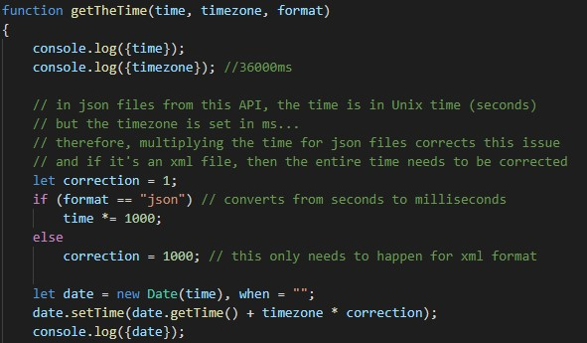

This took a little bit of playing around and guess work to get right, but basically the two API formats need to be corrected in slightly different ways. I found that I could get accurate times when a second-to-millisecond conversion was applied to the JSON API before the Date object was created. For the XML API, the same correction needed to be applied after Date object initialisation. Rather than creating an entirely new function for each API, I added an extra parameter to the relevant functions (getTheTime(), getTheHour(), getTheDate(), and getTheDayName()) so that the methods were usable for both formats.

2. Timezone issues with the JSON API

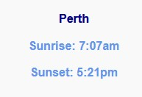 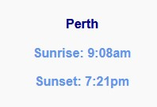

Sunrise and sunset for the XML API (left) and JSON API (right)



This issue has been solved by, when downloading from the JSON file, getting the sunrise and sunset hours based on the date.getUTCHours() method. An if statement checks what format is being used, and decides how to determine the hour of sunrise and sunset. This does not work properly for Central Australian Time, but unfortunately I need to accept this as 90% done so that I can make headway on the game assignment…